- Make heading green color like below in – ‘You may be here’ section and ‘tools we may use’ section:
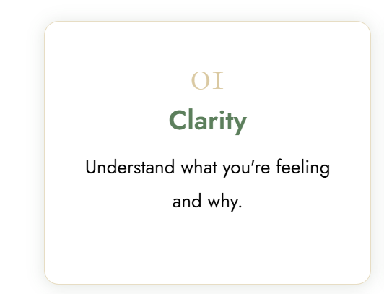
- Reduce the font size by 1 point of the headings on the boxes.
- Extend this box 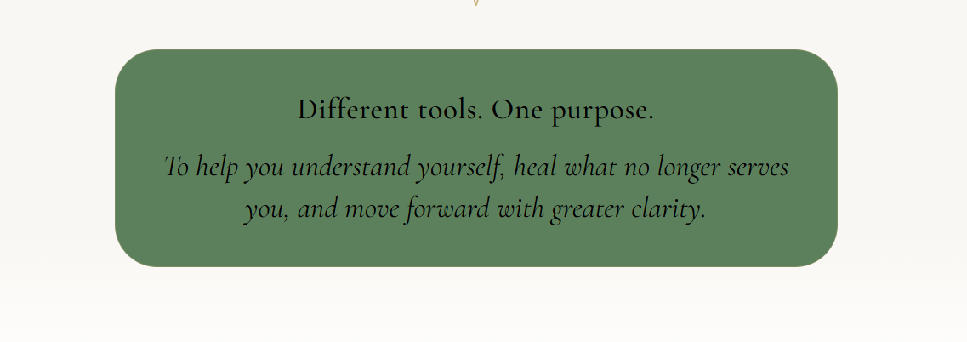
- Design the booking section like this one – left to right reading with CTA below. Also change the BKG color of this section.
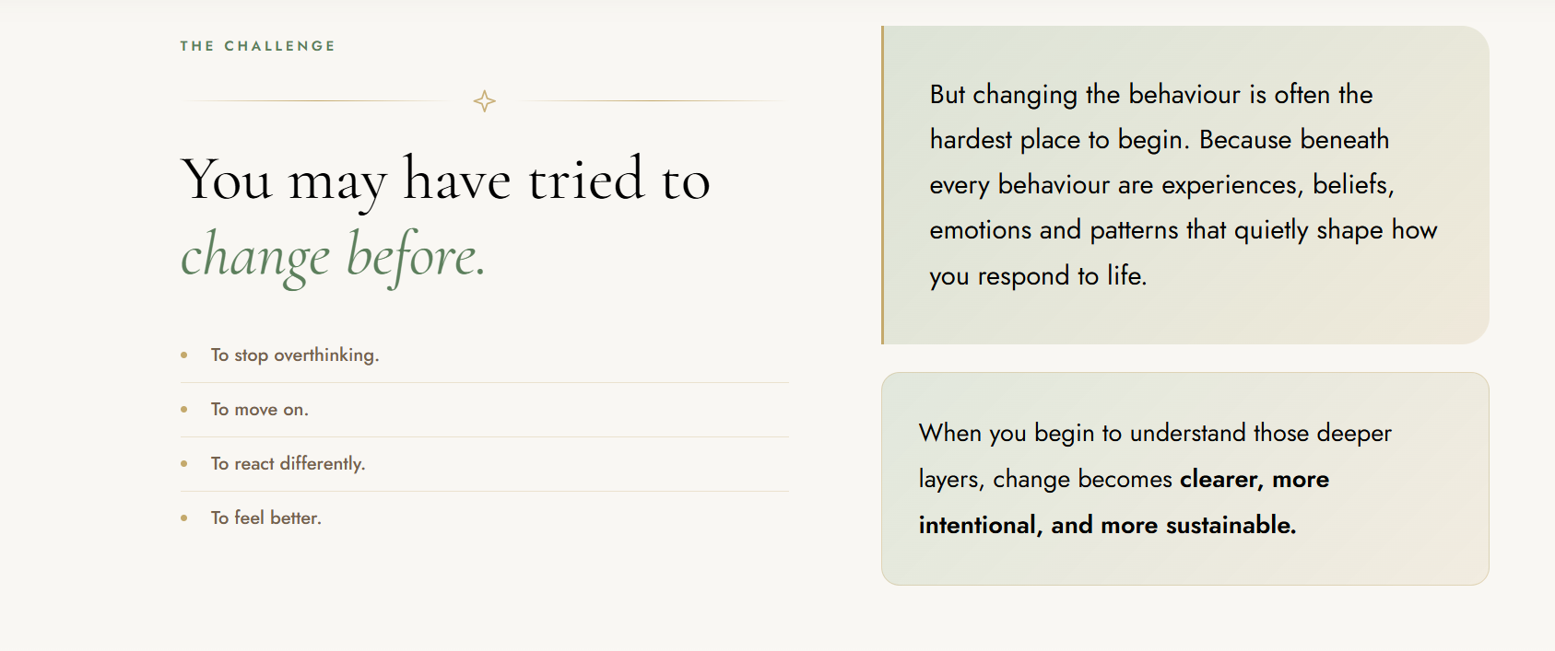

- Approach in the menu bar is wrongly linked.
- Banner is merging with header
- Wrong logo in about page header and footer
- Wrong logo in insights page header
- Remove animation and put the logo in image format
- Remove the background from banner section
- CTA in banner section to be of same color as in the intro – green. All three CTA’s on home page to be same color green.
- Correct the logo – it is distorted.
- Let’s make this color little lighter: 
- Footer Line below the logo –
A safe space to support a deeper shift in the way you think, feel, respond, relate and live.
- Change ‘Request a call’ to ‘Begin your journey’. And the link on menu isn’t working.
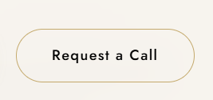
- Mobile version + alignment
- All booking CTA hyperlinked to connect page.
- CTA in about page –Only one CTA – Book your free consultation.

Requirements from me:
- Phone no: 9817835553
- Email: manila@enersoulhealing.com
- Location: Karnal, Haryana
- Fb Link:
https://www.facebook.com/share/1C1QeuBqiy/?mibextid=wwXIfr
- Insta Link: will update in the coming month. Page is WIP.

